**WRITTEN ANALYSIS**

**\*From the below charts it shows that all Top Performing Schools are Charter schools while bottom performing schools are District schools.**

## Scores by School Type

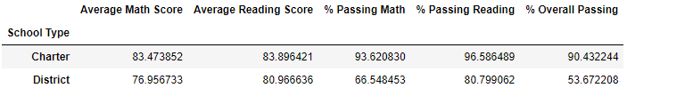

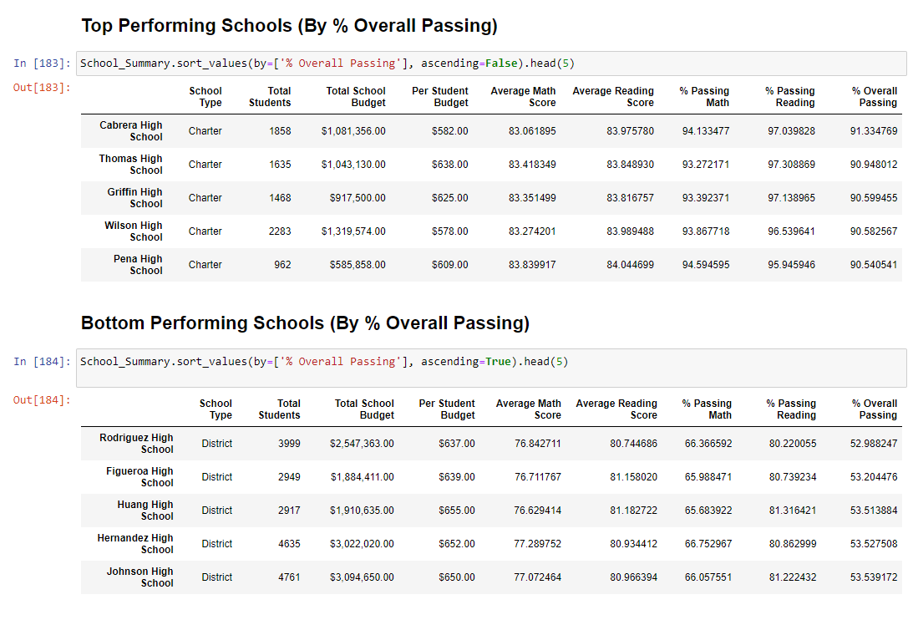**\*Average Reading scores are consistent across all grade levels, while math scores are consistently lower than the reading scores.**

Reading Score by Grade

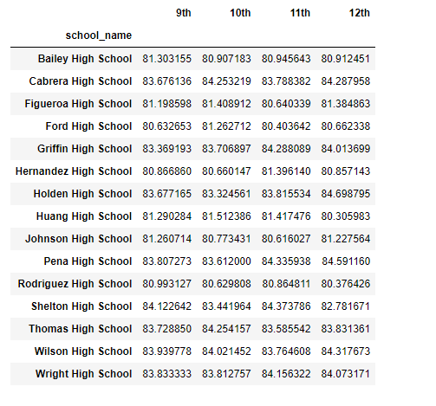

## Math Scores by Grade

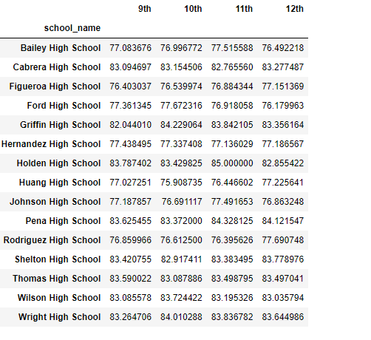

**\*The lesser the amount of money is spent on the students, the better overall passing rate the students have.**

## Scores by School Spending

## 

## *School size less than 2000 students have higher overall passing percentage

## *Scores by School Size

